|  |
| --- |
| **SEDCO**  **CVM TEAM**  **C# Windows Form Documentation**  **Survey Question Configurator**  **Mahdi Suleiman**  **Date: 25th May 2022** |

Table of Contents

Students' Property Right Declaration and Anti-Plagiarism Statement i

Abstract v

Chapter 1: User 1

Chapter 2: Admin & Installation 5

Chapter 3: Developer 10

References 35

# Abstract

Survey Question Configurator is a C# Windows Form Application for configuring 3 types of questions

1. Smiley Question, where you have to set:
   1. Question Order
   2. Question Text
   3. Number of smiley faces
2. Slider Question, where you have to set:
   1. Question Order
   2. Question Text
   3. Start Value
   4. Start Value Caption
   5. End Value
   6. End Value Caption
3. Stars Question:
   1. Question Order
   2. Question Text
   3. Number of smiley stars.

You can Add, Edit, View and Delete any question.

All changes are reflected to a Microsoft SQL server database.

**Keywords:**

Microsoft, C#, SQL, Windows Form

# Chapter 1: User

**1.1 Introduction**

The main idea of this project is to allow its user to view, add, edit and delete 4 types of the previously mentioned questions.

**1.2 How to use**

* First you have the main dialog. It has multiple controls and buttons divided into numbered sections:

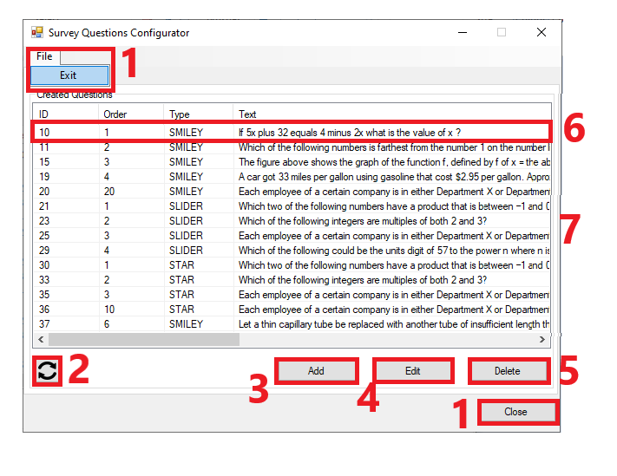

1. Close the application
2. Refresh questions list.
3. Add a question (Opens a new dialog).
4. Edit a **selected** question (Opens a new dialog).
5. Delete a **selected** question (Shows a conform dialog).
6. **Double clicking** a question open it’s **editing** dialog.
7. Horizontally resizable dialog.

* Second, if you press “**Add**” you will open “Add A Question” Dialog:

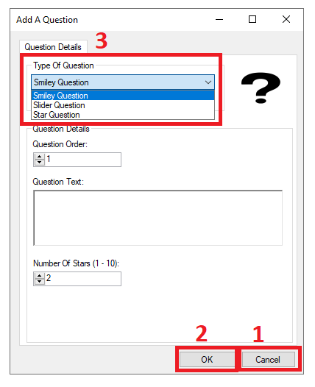

Also divided into 3 section:

1. Close the application.
2. Continue with your selections and inputs.
3. Choose the type of question you want to add.

* There is 3 types of questions to add.

1. Smiley faces question

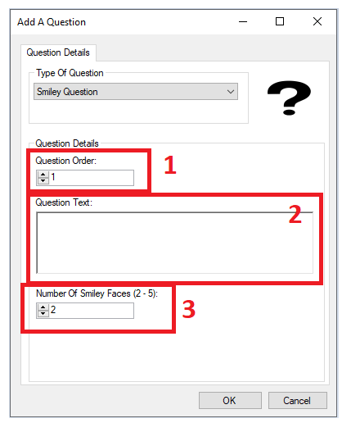

* 1. Order of the question.
  2. Text of the question.
  3. Number of smiley faces (2-5).

*Notes:

1. Questions orders can **NOT** repeat for every given question type.
2. Question text can **NOT** be empty.
3. Number of smiley faces **MUST** be in the range of (2-5) inclusive.
4. Slider question

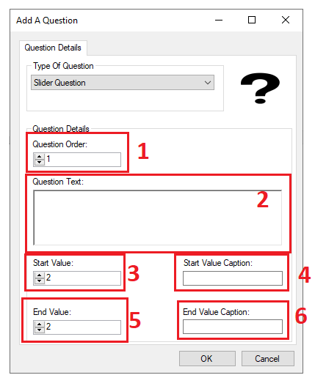

* 1. Order of the question.
  2. Text of the question.
  3. Star value of the slider (1-99).
  4. Start value caption.
  5. Star value of the slider (2-100).
  6. Start value caption.

*Notes:

1. Questions orders can **NOT** repeat for every given question type.
2. Question text can **NOT** be empty.
3. Start value caption and end value caption fields can **NOT** be empty.
4. Start value **MUST** be larger than end value.
5. Stars question

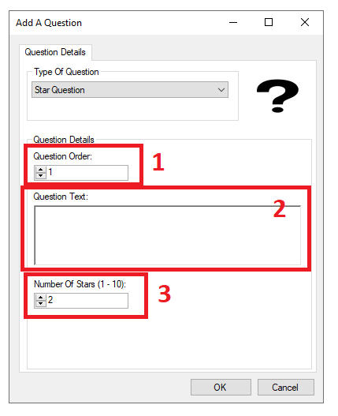

* 1. Order of the question.
  2. Text of the question.
  3. Number of stars (1-10).

*Notes:

1. Questions orders can **NOT** repeat for every given question type.
2. Question text can **NOT** be empty.
3. Number of stars **MUST** be in the range of (1-10) inclusive.

# Chapter 2: Admin & Installation

**2.1 Create & Prepare Database**

Run Database Script:

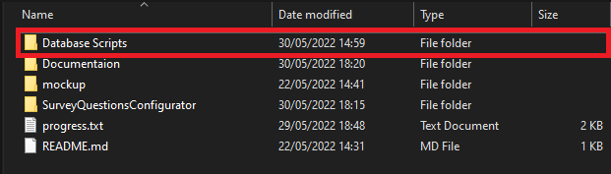

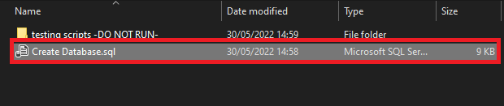

**2.2 Check Application’s Configuration File**

Make sure that “name” and “Database” attributes matches Database actual name in order for the application to start and work as intended.

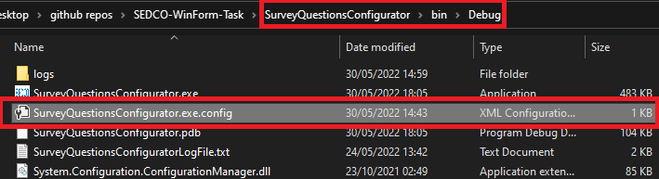

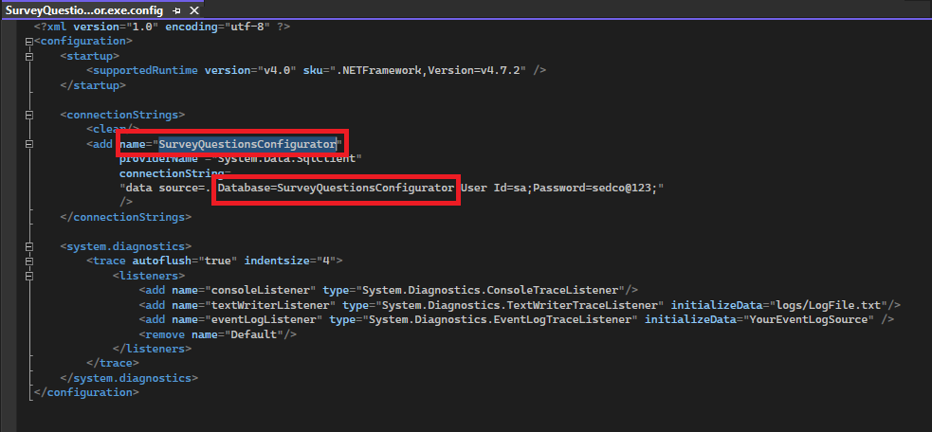

**2.3 Run Application’s Executable File**

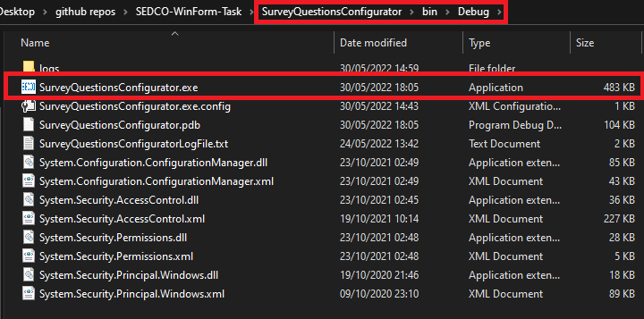

**2.4 Error Logs**

Error Logs can be found here.

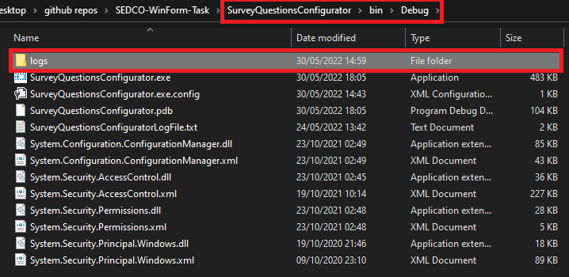

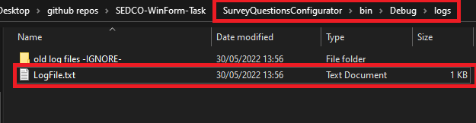

# Chapter 3: Developer

**3.1 Design Overview**

The figure below shows database entity-relation diagram.

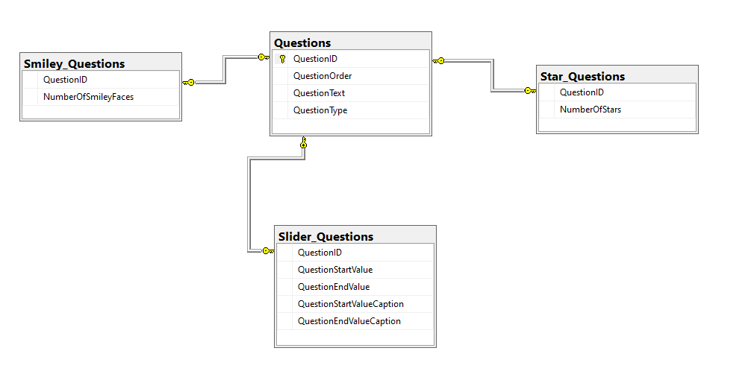

*Notes on tables:

* Questions table:

1. QuestionID is an auto increment primary key
2. QuestionOrder + QuestionType are a composed Unique key

* Smiley_Questions
  1. QuestionID is a Foreign + Unique key
  2. On update cascade
  3. On delete cascade
* Star_Questions
  1. QuestionID is a Foreign + Unique key
  2. On update cascade
  3. On delete cascade
* Slider_Questions
  1. QuestionID is a Foreign + Unique key
  2. On update cascade
  3. On delete cascade

**3.2 Design Details**

**3.2.1 Design Specifications**

**Table. 1** below shows our design specifications.

**Table. 1** Design Specifications

|  |  |
| --- | --- |
| **Aesthetic Factors** | * Convenient to use. * Basic color and layout. |
| **Cost** | * For us, hosting website services costs. * For students, the cost of lectures. * For tutors, the have around (15%) fees. |
| **Environment Factors** | * N/A |
| **Function** | * This project should allow students in remedial teaching. |
| **Manufacturing** | * It needed approximately 4 months to finish the design. |
| **Material** | * Visual studio. * Good knowledge in HTML, CSS, JavaScript, ASP.NET, C# and Database. * Internet connection. |
| **Safety** | * Available safety tools from Microsoft. |
| **Size** | * It is a website so you do not to install anything except a web browser. |
| **Customers** | * This project is aimed for students who are looking for good tutors. |

**3.2.2 Design Process**

In this section, we will describe the process of registration for students and tutors, how can students book lectures, and how the tutor accepts the order of student. First In **Figure. 5**, we are looking at Home Page for our project. The user can sign in, search for courses, explore tutors and study place.

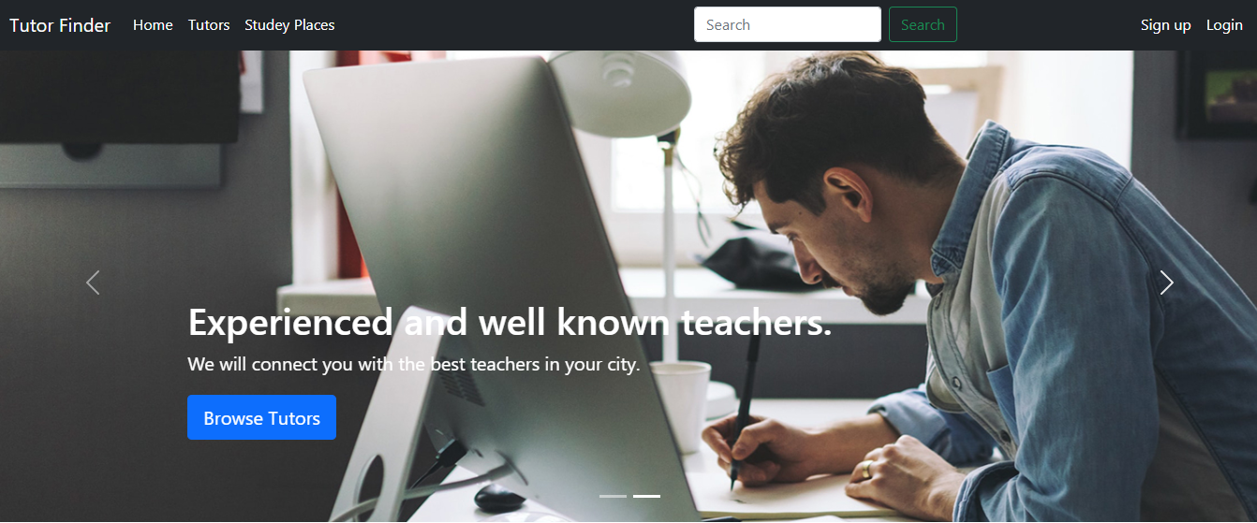

**Fig. 5** Home Page

Next in **Figure. 6**, we are looking at our student sign-up page.

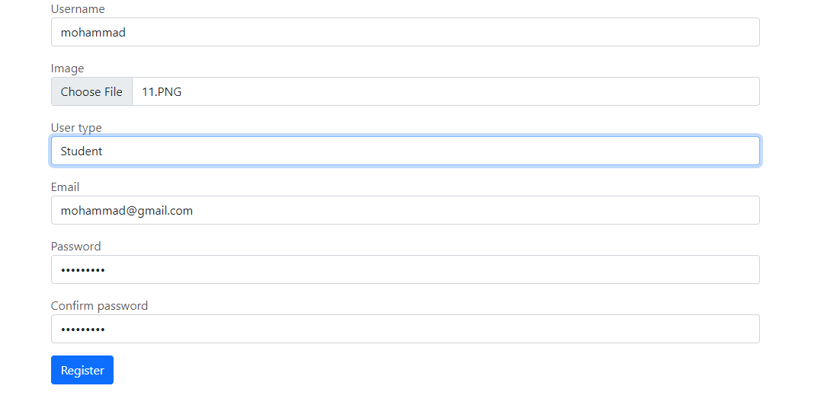

**Fig. 6** Sign up in student role

And **Figure. 7** shows tutor sign-up page.

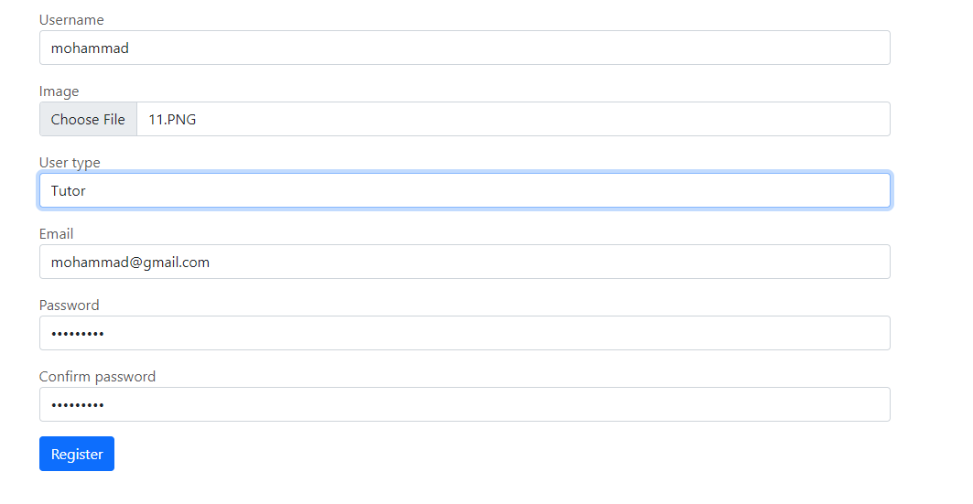

**Fig. 7** Sign up in tutor role

Next in **Figure. 8**, we can see our list of tutor page with a functioning search bar.

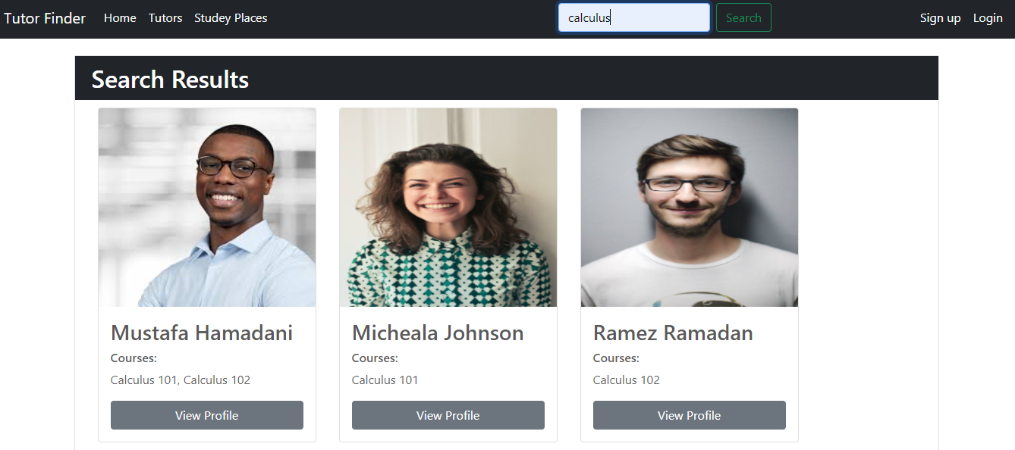

**Fig. 8** List ofTutors page and search bar functionality

Next in **Figure. 9**, we can see our study places.

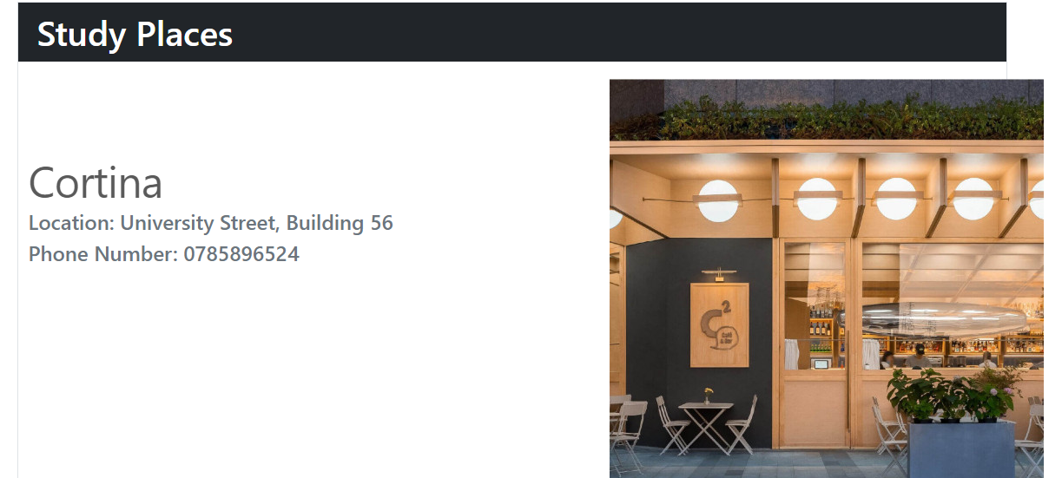

**Fig. 9** List of study places page

You can sign-in in our website by pressing on the sign-in icon. And you can choose the role that you want to sign-in with. After the user who registered and chosen "user type: student" now can book a lecture, and it is simply searching for the name of the topic and then the student finds a tutor when the student chose a tutor then the student can saw some details about the tutor and the price of an hour.

Next in **Figure. 10**, we are looking at tutor profile page.

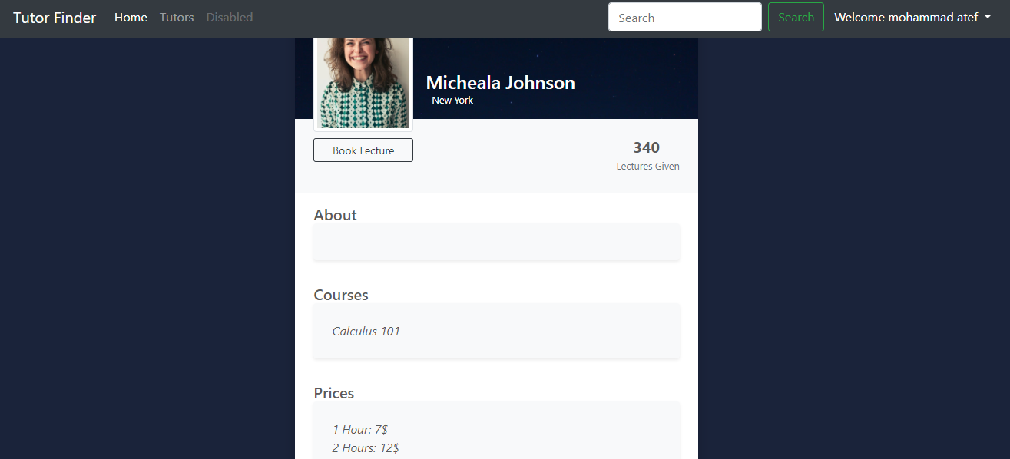

**Fig. 10** Tutor profile page

If the student is okay with the price of the lecture and want to book it, he can click on the **Book Lecture** button and then chose the suitable date, duration and study placed, then the student can click on the **Book** Button. **Figure. 11** below shows this process.

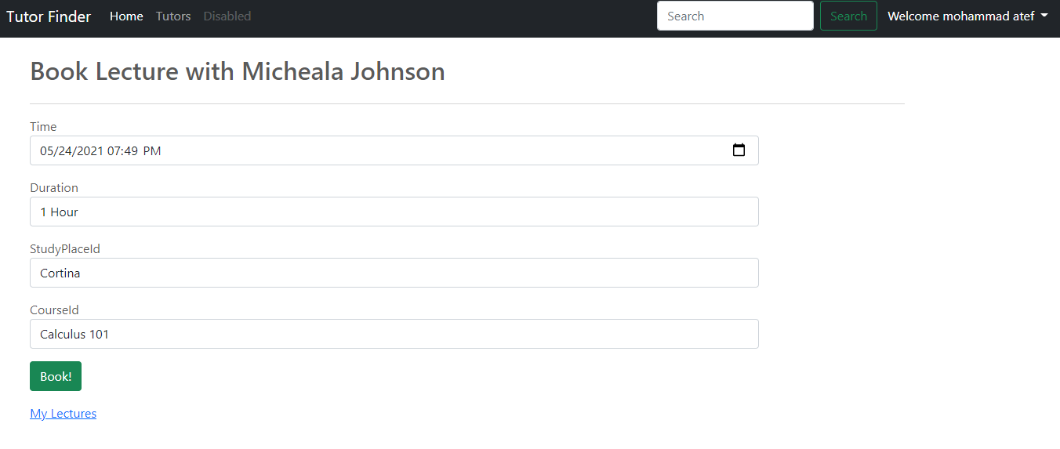

**Fig. 11** Book lecture page

Then, it will display a page containing the required lectures schedule and there is the status tab shows “Pending”. In this case, the student is waiting for the teacher’s response (acceptance or rejection). And the student can delete the lecture before any response from the tutor. As **Figure. 12** shows student’s lectures page.

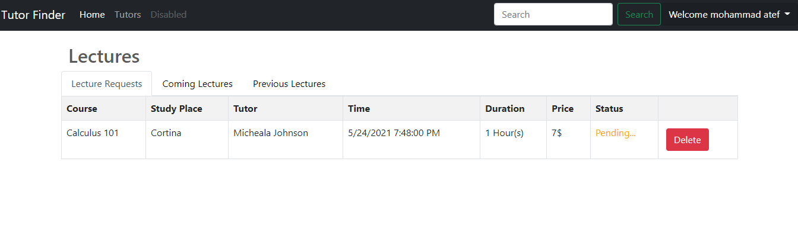

**Fig. 12** Lectures in student role

Now, as for the Tutor role in our website. The tutor can just sign in but without any privilege to insert any courses, because it is done by us (website admins), after we accept the tutor to our website, the tutor can open the lecture page to view, accept or decline student’s lecture request, and any action the tutor take is shown to the student real-time. As seen in **Figure. 13** below.

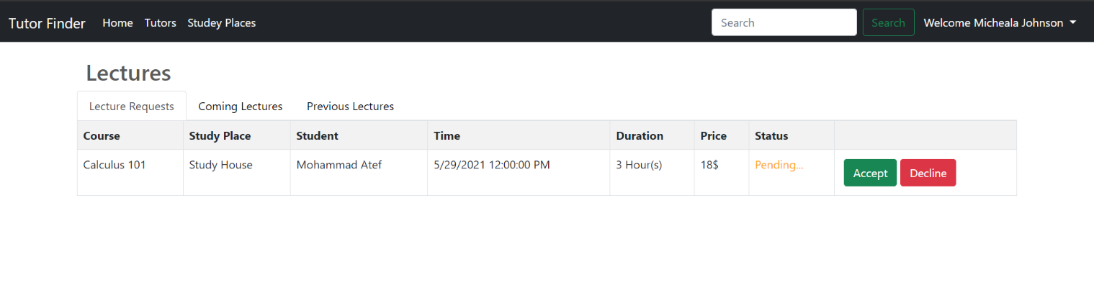

**Fig. 13** Lectures in tutor role

There are some advantages for tutors, and one of these features is to **edit the price** of the lecture according to what the tutor sees as appropriate. As shown in **Figure. 14** below.

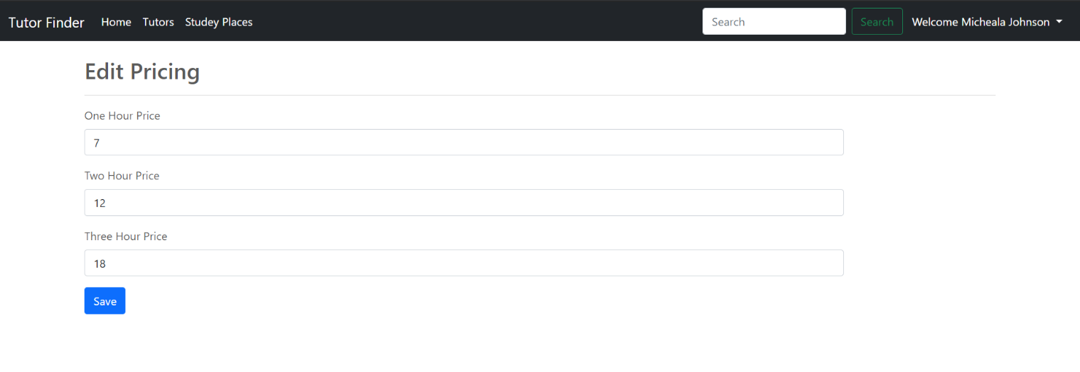

**Fig. 14** Edit pricing page

As for our role as Admins, we have special missions to do like.

1. Accept tutors sign-up request after we interview them personally.
2. Managing study places by inserting, deleting or editing their details.
3. Managing course by inserting, deleting or editing their details from tutors’ profile.

As seen in **Figure. 15** and **Figure. 16** below.

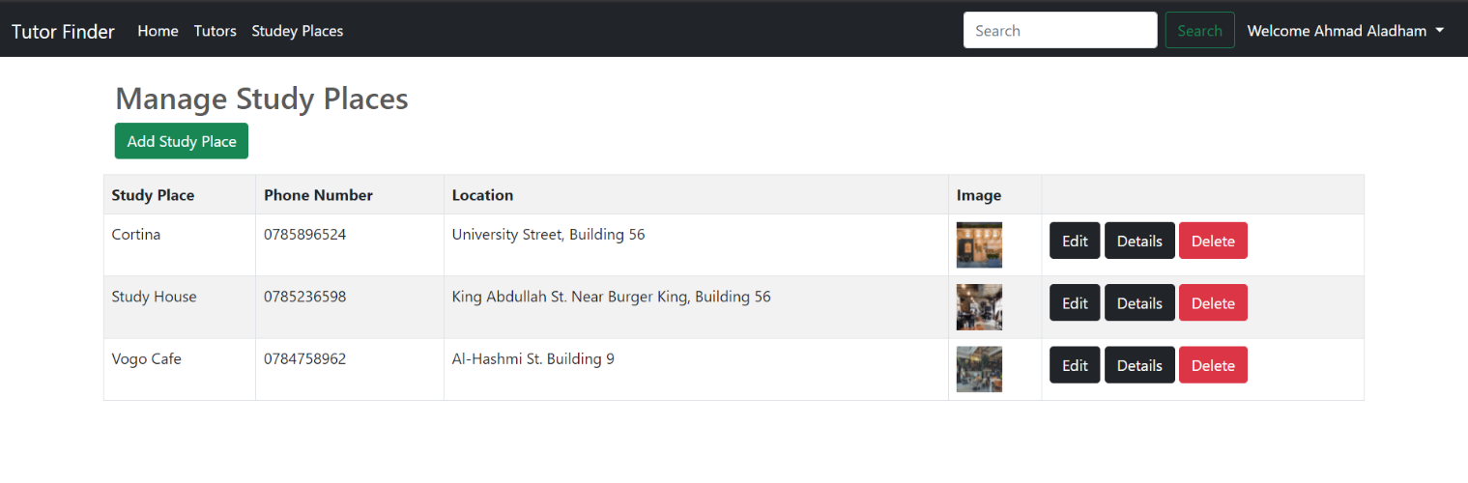 **Fig. 15** Manage study places page

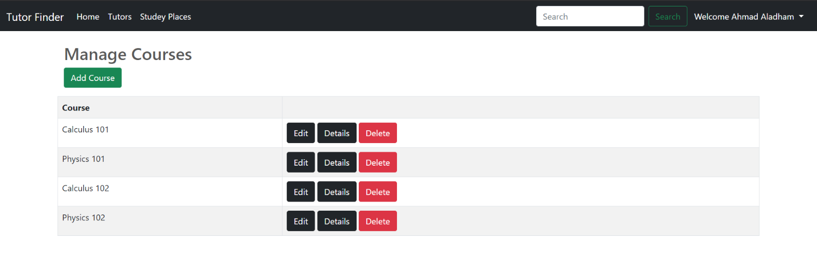

**Fig. 16** Manage courses page

**3.2.3 Legal Aspects**

In general, the website does not need access to too personal information about users but, the website will request a profile picture from its users in order to fill it in “image of account” field. If the user did not allow access to it, the user cannot continue the process of registration because the “photo of account” is required.

**3.2.4 Design Constraints**

In terms of security, we used Microsoft Identity for our accounts’ management which gives access to users depending on their role so that no one can make changes on the courses, study places and tutor courses but the admin. We did not ask for any sensitive information during the registration process which requires only first and last name, username, email, password, and a profile picture we only share the tutors’ profile pictures with other website users, and we keep everything else hidden inside our database tables. All the users’ passwords are hashed inside of our database tables and NOT stored as plaintext inside of the users’ table which make it more secure and does not allow anyone even the database managers from reading our users’ passwords. Our project is a website application, and it does not have environmental concerns or real-life limited resources, the only resources we need are a server which can handle the requests of all the current users which is a number that can vary depending on the success of our website.

**3.2.5 Design Standards**

In this project, some international standards were used, here is list of the standers:

1. The IEEE Stander Association (IEEE-SA): Multiple Stander were used.
2. Standards Engineering Society (SES): SES Web Privacy Policy

**3.2.6 Design Alternatives**

An Alternative to our website would be the idea of connecting tutors with students completely online and from all around the world, but the main idea of our website is to connect people that are close to each other and living in the same city which will omit the communication problem caused by tutors and students having different languages, and will make it easier for the student to understand any topic, we are starting in a small area with a small set of courses and study places here in Irbid and then we will expand to include all universities and cities of Jordan. This way we will benefit these talented but unknown tutors who are just starting their careers by suggesting them to locally related students, which will not happen in the case of making our website connect people globally as that will lead to our students taking lectures only with a small amount of fancy, well-known teachers.

There are not many design alternatives when it comes to our project, the idea is straightforward; our website is meant to connect tutors who are struggling to find students to teach and vice versa, we made it easy to find any tutor or course by simply searching their name. We can add a mobile application along with the website which is not an alternative but an addition to make it even easier for our tutors and students to use and connect with each other.

**3.2.7 Safety Consideration**

The main idea of this project providing good tutors for student, we choose the best tutor with us and sure the tutor had a nice experience in teaching. There are many tutors give remedial courses but a big number of them had not to experience or not qualify to teach student, so we want not that the student falls into this problem.

**3.2.8 Design Considerations table.**

**Table. 2** below Shows our design specifications.

**Table. 2** Design Considerations

|  |  |  |
| --- | --- | --- |
| **Design consideration** | **Project application** | **Relevant location in report** |
| Performance | Finding best tutors in local places. | Multiple locations. |
| serviceability | The project mainly serves university and college students. | Section 2.2 |
| Economic | This did not affect our design. | Section 7.2 |
| Environmental | This did not affect our design. | Section 6.4 |
| Environmental  Sustainability | This did not affect our design. | Section 6.4 |
| Manufacturability | This is not design criterion. | N/A |
| Ethical | No ethical constraints and guidelines are knowingly violated. | Section 6.2 |
| Health and safety | This did not affect our design. | N/A |
| Social | This did not affect our design. | N/A |
| Political | This did not affect our design. | N/A |

# References

[1] **Careem**

<https://www.careem.com/>

[2] **Uber**

<https://www.uber.com/>

[3] **Wikipedia MVC**

<https://en.wikipedia.org/wiki/Model%E2%80%93view%E2%80%93controller>

[4] **Microsoft ASP.NET MVC**

<https://docs.microsoft.com/en-us/aspnet/core/mvc/views/razor?view=aspnetcore-5.0#:~:text=Razor%20is%20a%20markup%20syntax,cshtml%20file%20extension>.

[5] **GoDaddy**

<https://ae.godaddy.com/>

[6] **GanttProject software**

<http://ganttproject.biz>